Part A — Practice Programs (Hour 1)
Work these in your lab-NN/ folder before the project: do the first one or two in the lab; the
last (For Advanced Learners) is for home.
1. Smart thermostat (Thermostat.java, main in this file)
(a) Create class Thermostat with private String location, private int temperature, private
static final int MIN=16 and MAX=30, and private static int activeCount=0.
(b) Constructor(location, startTemp): store location; set temperature to startTemp if it is
within MIN..MAX else 22; increment activeCount.
(c) Constructor(location): chain with this(location, 22).
(d) raise(): if temperature < MAX add 1, else print “Already at maximum (30)”.
(e) lower(): if temperature > MIN subtract 1, else print “Already at minimum (16)”.
(f) Add getTemperature() (no setter) and static getActiveCount().
(g) In main: create two thermostats, call raise() 10 times then lower() 20 times in loops
(printing the temperature each time), then print getActiveCount().
CO1
PO1,
PO2,
PO3
Practical
Number CO/PO
Expected output: temperature rises to 30 then “Already at maximum”, falls to 16
then “Already at minimum”, count 2.

import java.util.Scanner;
import java.lang.String;
class first
{
private String location;
private int temp;
private static final int Min=16,Max=30;
private static int activecount=0;
//static int starttemp=0;
public first(String location , int temp) {
this.temp = temp;
this.location = location;
if (temp >= Min && temp <= Max) {
this.temp = temp;
activecount++;
} else {
this.temp = 22;
}
}
void raise()
{
if(temp<Max)
{
temp=temp+1;
}
else
{
System.out.println("The temperature is already Maximum");
}
}
void lower()
{
if(temp>Min)
{
temp=temp-1;
}
else {
System.out.println("The temperature is already minimum");
}
}
void getTemperature()
{
System.out.println("The current temperature is : "+temp);
}
}
public class thermostat
{
public static void main(String[] args)
{
String location;
int temp=0;
int input=-1;
Scanner sc=new Scanner(System.in);
System.out.println("Enter the location of area: ");
location=sc.next();
System.out.println("Enter the temperature :");
temp=sc.nextInt();
first y=new first(location,temp);
System.out.println("Enter 1 to raise temp , 2 for lower temp , 3 to check the temo and 0 to exit : ");
while(input!=0)
{
input=sc.nextInt();

switch(input)
{
case 1:
{
y.raise();
break;
}
case 2:
{
y.lower();
break;
}
case 3:
{
y.getTemperature();
break;
}
case 0:
{
System.out.println("Exiting....");
break;
}
}
}
sc.close();
}
}

OUTPUT:
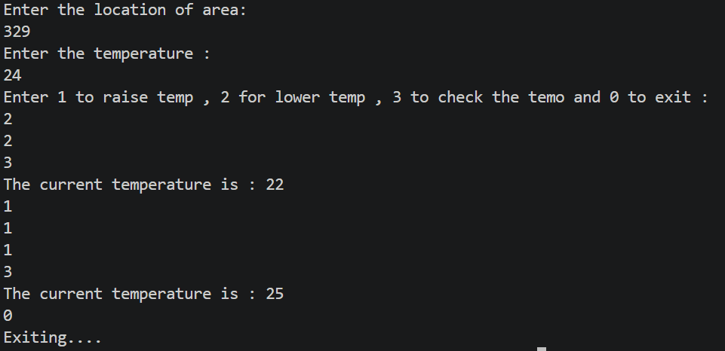
2. Cinema show (CinemaShow.java, main in this file)
(a) Create class CinemaShow with private String title, private int seatsAvailable, private
final int capacity, and private static int totalBooked=0.
(b) Constructor(title, capacity): set both and seatsAvailable = capacity.
Constructor(title): chain with this(title, 100).
(c) book(int n): if n ≤ seatsAvailable, reduce seatsAvailable by n, add n to totalBooked,
return true; else return false unchanged.
(d) cancel(int n): increase seatsAvailable by n but never above capacity.
(e) Add getSeatsAvailable() and static getTotalBooked().
(f) In main: run a sequence of book and cancel calls, printing the result and seats after
each, then print getTotalBooked().
Expected output: booking more than available prints false and leaves seats
unchanged; totalBooked equals the successful bookings.
public class CinemaShow {

private String title;
private int seatsAvailable;
private final int capacity;
private static int totalBooked = 0;

// Constructor with title and capacity
CinemaShow(String title, int capacity) {
this.title = title;
this.capacity = capacity;
this.seatsAvailable = capacity;
}

// Constructor chaining
CinemaShow(String title) {
this(title, 100);
}

// Book seats
boolean book(int n) {
if (n <= seatsAvailable) {
seatsAvailable = seatsAvailable - n;
totalBooked = totalBooked + n;
return true;
}
else {
return false;
}
}

// Cancel seats
void cancel(int n) {
seatsAvailable = seatsAvailable + n;

if (seatsAvailable > capacity) {
seatsAvailable = capacity;
}
}

// Getter
int getSeatsAvailable() {
return seatsAvailable;
}

// Static getter
static int getTotalBooked() {
return totalBooked;
}

// Main method
public static void main(String[] args) {

CinemaShow show = new CinemaShow("Avengers", 50);

System.out.println(show.book(20));
System.out.println("Seats: " + show.getSeatsAvailable());

System.out.println(show.book(15));
System.out.println("Seats: " + show.getSeatsAvailable());

System.out.println(show.book(20));
System.out.println("Seats: " + show.getSeatsAvailable());

show.cancel(10);
System.out.println("After cancellation: " + show.getSeatsAvailable());

System.out.println(show.book(15));
System.out.println("Seats: " + show.getSeatsAvailable());

System.out.println("Total booked: " + CinemaShow.getTotalBooked());
}
}

OUTPUT:
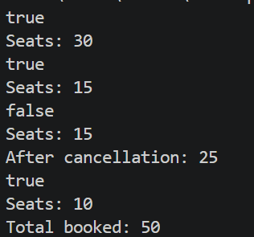

Key Questions / Analysis / Interpretation :
1. What is encapsulation, and how do private fields with public getters enforce it?
Encapsulation means wrapping data and methods into one class. Private fields prevent direct external access, while public getters allow controlled reading of data.
2. Why is accountNumber declared final?
It is declared final because an account number should be assigned once and should not change after initialization.
3. What is the difference between a static field and an instance field when generating IDs?
A static field is shared by all objects of a class, while an instance field belongs to each object. A static counter generates unique IDs across multiple objects.

